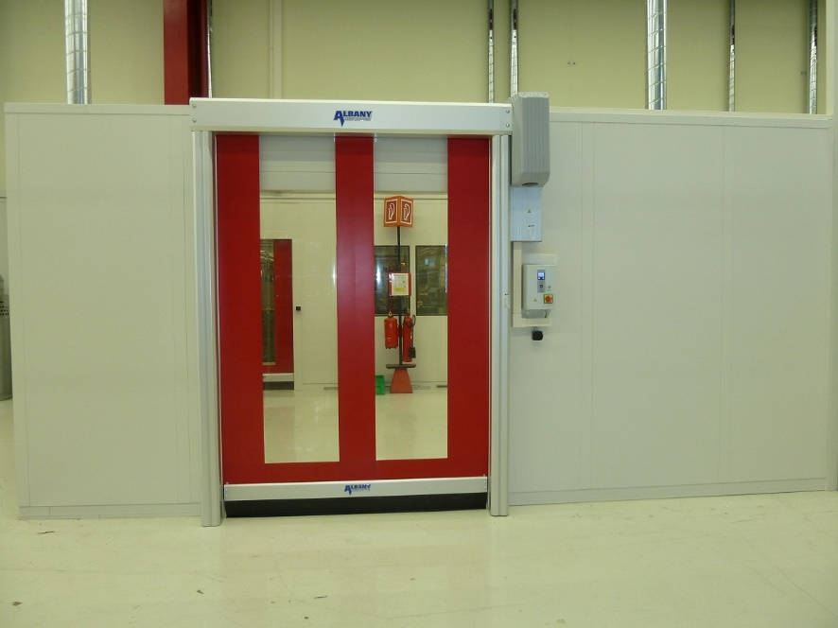

NIHVA - ASSA ABLOY – High Speed Door - RR300+ AL
(100% Imported – made in Germany)
Description:

Flexible High-performance door, opening in vertical direction for Internal use in wind-protected areas.

Self-supporting side frames made of galvanized steel

Door curtain made of transparent PVC with fabric reinforcement stripes, ultramarine (similar to RAL 5002) or red (similar to RAL 3002).

Top roll made of anodized aluminum.

Wind protection: wind tabs on the door curtain.

Wind resistance: class 1 (EN 12424).

Bottom profile: anodized aluminum.

Drive unit: Hollow shaft gear motor.

Protection: IP 55

Safety devices:
electrical safety contact edge, evaluation via integrated cable chain, door line photocell in the side frames, drop down protection by integrated balancing system.

Covers
Top roll cover required
Motor cover required

Control system:
Frequency converter control system Albany MCC, based on vector control including boost function at start-up. Graphic display and foil keypad for easy guided operation. Easy access to all important information for operation and service.

Opening and Closing Speed:

(open/close) up to max. 2,2/0,9 m/s

Supply voltage

3L(N)PE/380/400/415/440/480V;50/60Hz,
Transformer necessary for 220/230/500V

